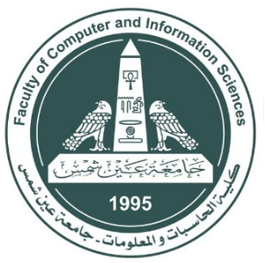

|  |  |
| --- | --- |
| Faculty of Computer & Information Sciences  Ain Shams University  Subject: CSC360  Compilers’ Theory | Examiners: Prof. Zaki Taha  Dr. Sally Saad  Academic year: 1st term 2021-2022  Year: 3ed undergraduate |

**Compilers’ Theory**

**Milestone -1-**

**2. TINY DFAs**

1 - Number: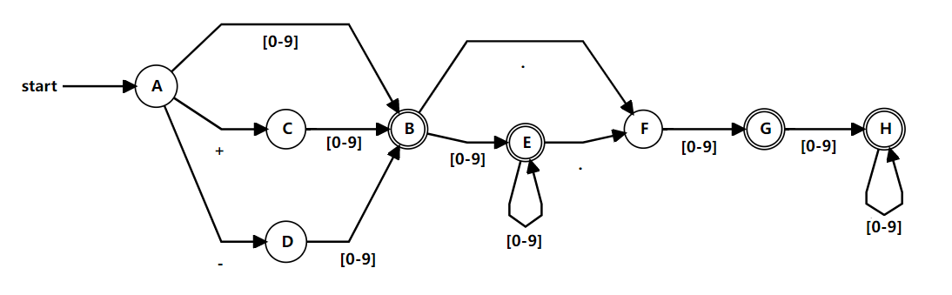

=======================================================

2) String: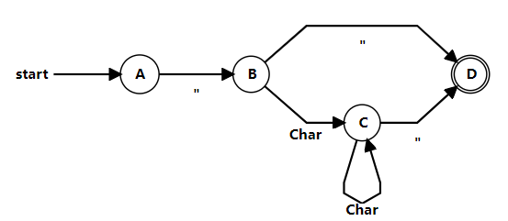

=======================================================

3) Identifiers: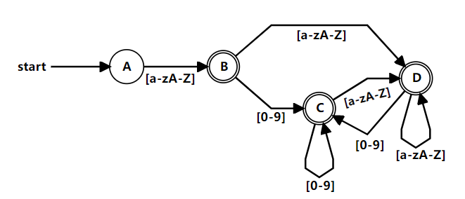

=======================================================

4) Comment statement :

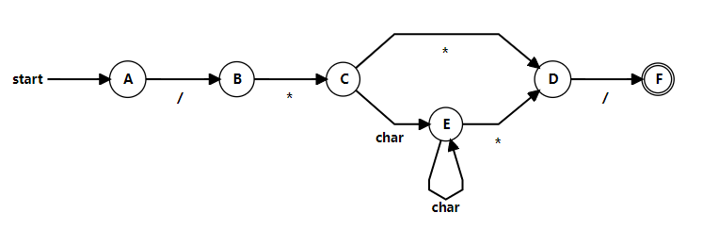

=======================================================

5) Arithmetic Operators: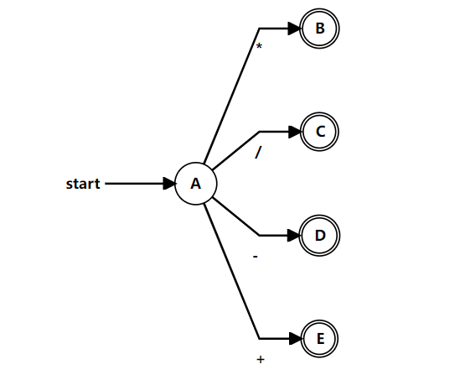

=======================================================

6) Condition Operators :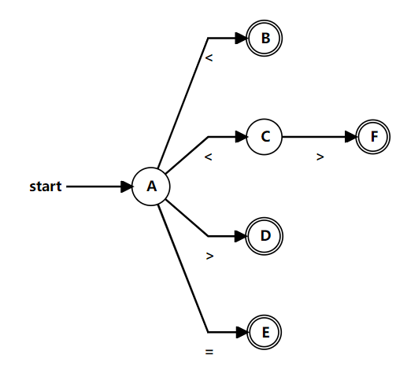

=======================================================

7) Boolean Operator 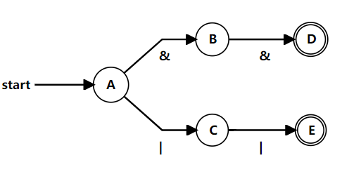

=======================================================

8) Reserved Words

